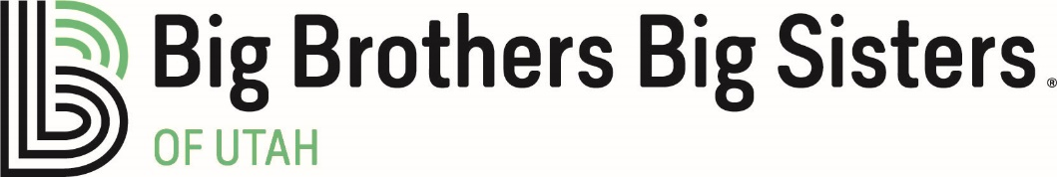

Job Description

Position Title: Satellite Manager – Southern Utah
Position Classification: Exempt
Work Schedule: 40 hours a week
Supervisor: Chief Operating Officer
Updated: February 2020

Broad Functions:
This position is responsible for program implementation, fundraising and community development in Southern Utah. This person will work closely with a local board of volunteers to assist in realizing goals of serving children and raising the necessary funds to make this happen. The incumbent will work very closely with the State Office in realizing and setting goals according to a strategic plan approved by the BBBSU Board of Directors.

Community Development and Fundraising Responsibilities – 50% of total time
- In collaboration with CEO & COO, build and lead Southern Utah Advisory Board
- Coordinate with Development staff, Southern Utah Advisory Board and committees for annual fundraising activities for the region and agency
  - Bowl for Kids’ Sake each spring and Fall Fundraiser (currently trivia night)
  - Manage and Steward local Foundation and Corporate contacts in conjunction with State-wide Fund Development staff
  - Manage and Steward local individual donors in conjunction with State-wide Fund Development staff
- Identify and promote re-engagement of volunteers as Bigs, board members, donors and in other volunteer capacities.
- Assist in tracking and completing information for reports to funders
- Create and maintain a high level of involvement in Washington County. (ex. Chambers of Commerce, professional networking organizations, PTA meetings, collaboration meetings, city council meetings, back to school nights etc.)
- Strategize and implement an outreach and volunteer recruitment plan suitable for the communities served
- Provide oversight to regional and agency-sponsored match activities, providing ongoing opportunities for group interaction and agency affiliation
- Represent BBBSU on community councils as needed

Program Responsibilities – 35% of total time
- Oversee all program functions of customer relations, enrollment and matching and support activities to ensure: child safety, relationship development and appropriate child development and strengthen ties to BBBSU for both the volunteers and children and families served.
- Ensure high-level proficiency in applying child safety and risk management knowledge, policies and procedures throughout all aspects of job function.
- Establish Relationships with Elementary and High Schools for the site-based mentoring programs.
- Lead the regional enrollment and matching team to provide high-level customer service through effective implementation of volunteer and child enrollment, matching, and support in accordance with BBBSA Standards of Practice, the Service Delivery Model, and BBBSU policies.
- Responsible for monitoring and reporting program metrics and progress and identifying and eliminating barriers toward regional program goals.
- 5-10% of time will be spent in direct program work (Enrollment and/or Match Support)
- Implement and promote match activities to support ongoing volunteer involvement through individualized recognition, annual events, and reengagement strategies.

Donation Center Supervision – 15% of total time
- Supervise Driver and ADS staff located in Southern Utah
- Steward current bin location partners and clothing donors
- Seek out and place new bin location partnerships
- Work to establish additional clothing drive partnerships

Job Qualifications
Minimum Bachelors degree in social services, human resources or related field, Masters Degree and or 3 + years progressive leadership experience preferred. Experience supervising staff and/or volunteers. Relationship Building, Fundraising and or Sales experience preferred. Experience working with both child and adult populations; specific assessment, intake or interview experience, preferred. Proficiency in Microsoft OFFICE; including Word, Outlook, and Excel. Must have transportation, and meet state required automobile insurance minimums, to travel to communities for services.

Required Skills and Abilities
Excellent oral and written communication skills, reflecting solid customer service and high-level interviewing skills; ability to: form appropriate assessment-based relationships; relate well in multicultural environments; maintain confidentiality throughout daily operations; effectively collaborate with other volunteer match staff; use time effectively; and focus on details. Ability to collect meaningful data and draw solid conclusions.

Work Environment
Routine office environment. Flexible work hours to meet customer needs. Travel as needed to visit clients in homes and participate in community events.

To apply please send a resume and cover letter to Lauren Holman at Lauren.Holman@bbbsu.org
10/2020

